F-LAN CHINESE CURRICULUM PROJECT
LEVEL 3 - MY EXTENDED WORLD (PART 2)

Unit 1:
Integrated Performance Assessment

Novice Novice Novice Intermediate Intermediate Intermediate
Low ➔ Mid ➔ High ➔ Low ➔ Mid ➔ High ➔

Learning Targets:

- I can demonstrate comprehension of a reading passage about Chinese students’ school life
- I can converse about Chinese students’ academic and extracurricular activities
- I can write a journal entry about Chinese students’ academic and extracurricular activities
- I can give an oral presentation introducing their school life
- I can compare and contrast Chinese and American high school students’ academic and extracurricular activities.

Task Overview

Your school and your sister school in Xi’an are planning to have a collaborative project tutoring some elementary students in the summer. You and other classmates are chosen to represent your school. Together with students from your sister school, you will be working as a team to do this volunteer service project. To increase mutual understanding and foster friendship, the Chinese teammates write you a letter that introduce themselves and their high school life.

After several weeks you leave for China. The Chinese students meet you at the Xianyang International Airport. On the way to the hotel on the bus, intriguing conversations unfold and you share and exchange many viewpoints regarding Sino-American teenagers’ life.

Time flies, three weeks of this service project ends. On your flight back to America, you reflect on the past three weeks and write a journal entry about the similarities and differences between Chinese and American high school students’ lives as well as on your Chinese learning experience.As the new school year starts, your Chinese teacher asks you to share your China trip by giving a speech to the class.

Interpretive Reading Task (Reading text plus questions):

Your school and your sister school in Xi’an collaborate to have service project tutoring some elementary students in the summer. Students from your school and students from the sister school are assigned to work together as a team. To increase mutual understanding and foster friendship, your Chinese counterparts sent you a letter with their time schedule introducing themselves and their high school life.

亲爱的美国同学们：

你们好！
很高兴今年暑假我们一起做义工，能认识美国朋友，让我们兴奋。
我们先介绍一下我们自己和我们的学校。我们是：李阳、吴小山和林海。我们上高一，是同班同学。最有意思的是：我们三个人从小学到初中到高中，一直是同班同学！所以我们是最好的朋友。我们希望用功学习，以后一起上大学，上同一所最好的大学！
为了上大学我们要考高考。准备高考的压力很大，因为有很多作业，每天都非常忙。不是笔试就是口试，不是写作文就是交报告。忙是忙，累是累，可是我们还是很开心，因为我们三个人每天在一起上课，学一样的课，做一样的作业。我们学高中语文、数学、物理、化学、历史、地理、英文等等。而且，我们有很多共同爱好和兴趣。比如：我们都对语言感兴趣。除了喜欢中文以外，还对英文感兴趣。因为我们都很用功，所以我们的成绩很好。
除了学习，我们也想玩儿，可是没有太多时间玩儿。因为在中国，高中生的高考压力大，没有什么课外活动。还好，我们学校每年举办春秋两季运动会。开运动会的时候，有很多田径和球类比赛，运动场上非常热闹。在那三天，我们的班级就是我们的团队，大家都很有团队精神，因为我们都希望赢，不喜欢输。我们最喜欢学校运动会，因为又不上课，又整天运动，好开心啊。
亲爱的美国同学们，我们在暑假的四个星期里，一起帮助小学生学习英文，也会互相学习语言，我们越想越有意思。我们很好奇，很想知道你们为什么学中文？写繁体字还是写简体字？学笔顺、笔画、声调和发音有用吗？我们还想问你们：怎样练习可以说流利的英文？记住多少英文词汇就可以听说读写？我们还想跟你们比较一下中文和英文的语法。英文的语法为什么那么难？
西安是一座古城，历史悠久，有很多文化古迹，而且美食也很有名。我们去做义工的学校在市中心，离我们的高中不远。西安欢迎你们！我们欢迎你们！
祝大家学习进步！暑假愉快！早日相见！

李阳、吴小山、林海
二零一四年四月十日

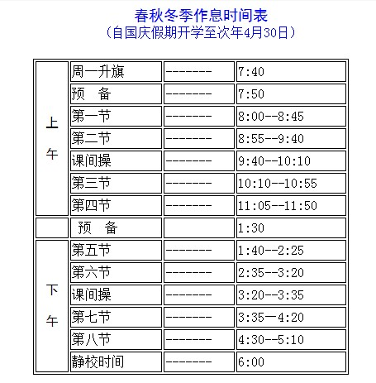

十个问题 10 comprehension questions:

- 谁是写信人？谁是发/收信人？
- 为什么写这封信？
- 为什么很多中国学生从小学到大学都可能是同班同学？（比较好处和坏处？）
- 为什么中国高中生没有时间参加课外活动？
- 中国学生在运动会时为什么有团队精神？
- 中国学校和美国学校还有什么不同？
- 中国高中的课程和你的一样吗？写出一样和不一样。
- 如果你去中国学校学习半年，你怎样安排？
- 如果你去中国一个月，你怎样安排？

Interpersonal Speaking and Listening Task:

As your Chinese teammates meet you at the Xiyang International Airport, you can’t wait to know them better by engaging in conversation. On the way to your hotel, you exchange thoughts about commonalities and differences between Chinese and American high school students’ life, as well as share your experience in learning Chinese/English (as second language), and ask many questions.

Presentational Writing Task:

Time flies, the three-week volunteering project now comes to a close. On the plan back to Salt Lake City, you can’t help pondering about how much you’ve learned in this trip. Contemplating about this incredible experience, you begin to write a journal entry, reflecting on the similarities and differences between Chinese and American high schoolers’ lives.

Presentational Speaking Task:

As the new school year starts, your Chinese teacher asks you to share about your China trip - what you have observed and learned about similarities and differences between Sino-American teeangers’ lives at school routines and in extra curricular activities. Consequently, you give a presentational speech reflecting on these issues.

